Wireshark assignment 2.
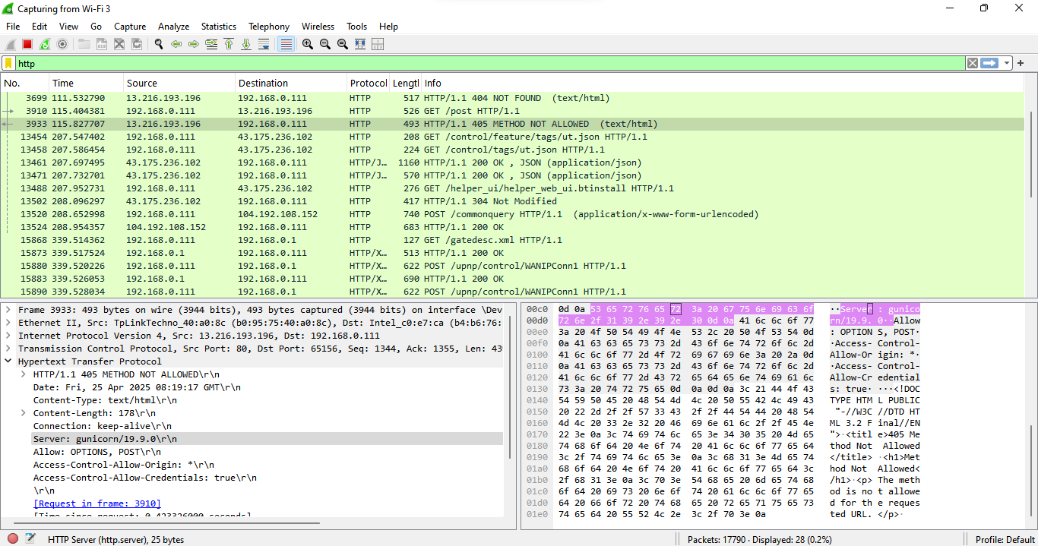

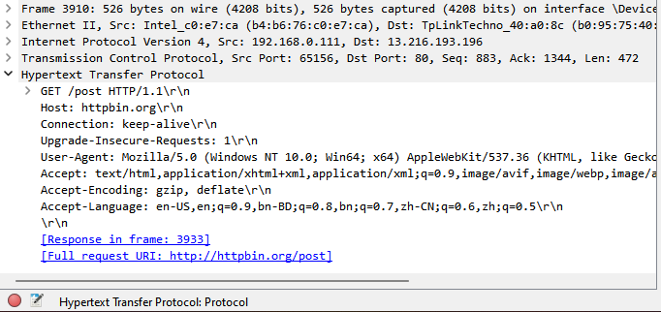

Http get request.
GET /get HTTP/1.1\r\n
Host: httpbin.org\r\n
User-Agent: Mozilla/5.0 [Windows NT 10.0; Win64; x64] AppleWebKit/537.36 (KHTML, like Gecko) Chrome/135.0.0.0 Safari/537.36\r\n
Accept: text/html, application/xhtml+xml, application/xml;q=0.9, image avif, image/webp,image/apng,/;q=0.8,application/signed-exchange;v=b3;q=0.7\r\n
Accept-Encoding: gzip, deflate\r\n/
Connection: keep-alive\r\n
Response header.
HTTP/1.1 200 OK
Date: [timestamp]
Content-Type: application/json
Content-Length: [length]
Connection: keep-alive
Server: gunicorn/19.9.0

Post Request Header
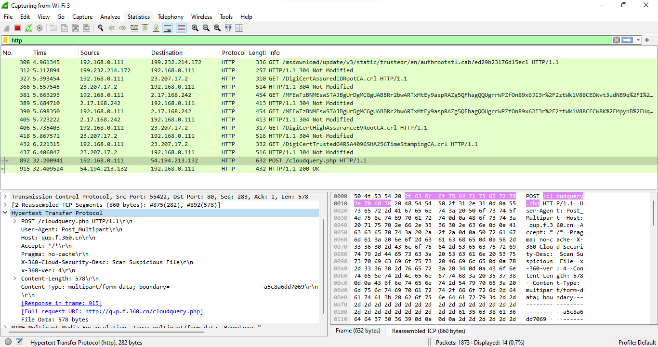
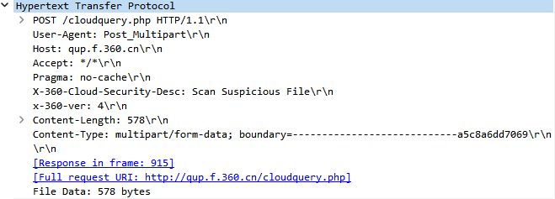
Post response Header

b)
GET Response MIME Type: application/json
POST Response MIME Type: application/json

c)
Status Code: 200 OK
Explanation: This indicates that the request was successful and the server returned the requested resource (for GET) or processed the data (for POST) properly.

